Bandit Level 0
DG Interns Hub | Week 1 | OverTheWire Bandit Writeup

Objective
Connect to the Bandit SSH server.

Activity summary
Suggested learning command / approach: ssh bandit0@bandit.labs.overthewire.org -p 2220. Use only on the authorized OverTheWire training environment.

Key learning
SSH login and terminal access.

Evidence
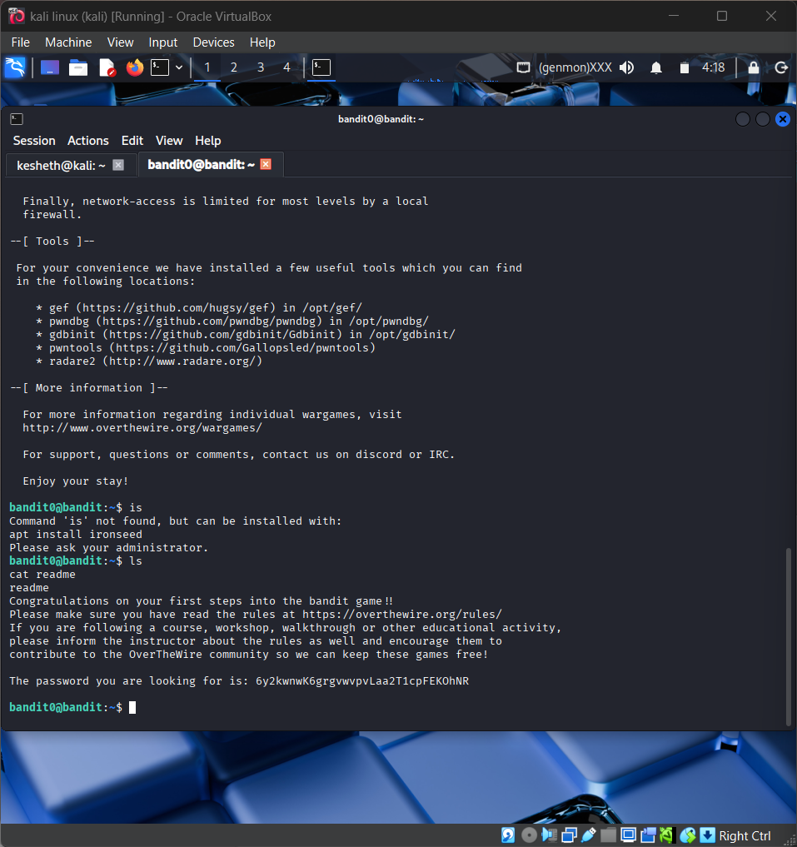
Screenshot: bandit level0.png
The screenshot is evidence of level activity/login; it may not show every solution step. No passwords are reproduced.

